LAB SHEET – 5
Subject: Database Management System (DBMS)
Q1. Basic Inner Join
Display employee names, department names, and department loca ons for employees with matching departments.
SQL Command:
SELECT Employees.EmpName,
Departments.DeptName,
Departments.Location
FROM Employees
INNER JOIN Departments
ON Employees.DeptID = Departments.DeptID;

OUTPUT:
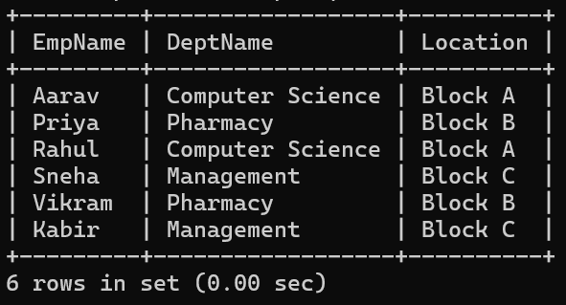

Q2. Employee and Department IDs
Use INNER JOIN to display EmpID, EmpName, DeptID, and DeptName.
SQL Command:
SELECT Employees.EmpID,
Employees.EmpName,
Employees.DeptID,
Departments.DeptName
FROM Employees
INNER JOIN Departments
ON Employees.DeptID = Departments.DeptID

OUTPUT:
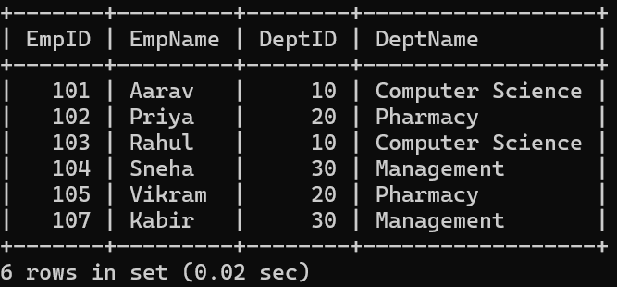

Q3. Pharmacy Employees
Use INNER JOIN and WHERE to display employees belonging to the Pharmacy department.
SQL Command:
SELECT Employees.EmpID,
Employees.EmpName,
Departments.DeptName
FROM Employees
INNER JOIN Departments
ON Employees.DeptID = Departments.DeptID
WHERE Departments.DeptName = 'Pharmacy';
OUTPUT:
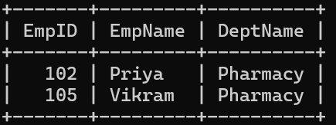

Q4. Salary Filter
Display matched employees whose salary is greater than 60000.
SQL Command:
SELECT Employees.EmpID,
Employees.EmpName,
Employees.Salary,
Departments.DeptName
FROM Employees
INNER JOIN Departments
ON Employees.DeptID = Departments.DeptID
WHERE Employees.Salary > 60000;
OUTPUT:
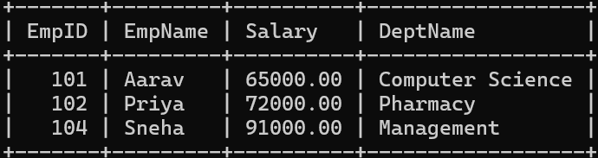

Q5. Equi Join
Perform an Equi Join between Employees and Departments using DeptID = DeptID.
SQL Command:
SELECT Employees.EmpID,
Employees.EmpName,
Employees.DeptID,
Departments.DeptName
FROM Employees
INNER JOIN Departments
ON Employees.DeptID = Departments.DeptID;
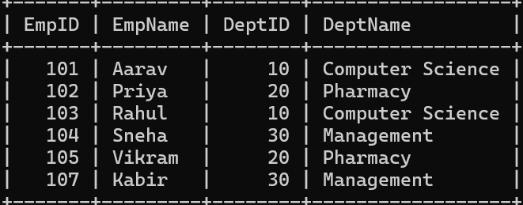

Q6. Equi Join with Multiple Columns
Display employee name, employee city, department name, and department loca on using an equality based join.
SQL Command:
SELECT Employees.EmpName,
Employees.City,
Departments.DeptName,
Departments.Location
FROM Employees
INNER JOIN Departments
ON Employees.DeptID = Departments.DeptID;
OUTPUT:
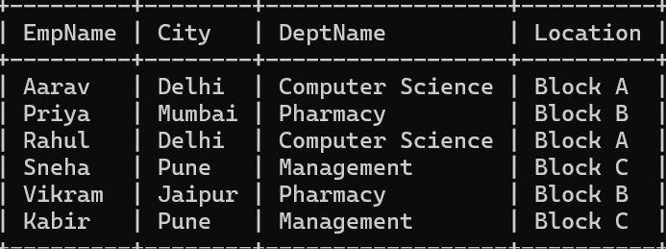

Q7. Computer Science
Find all employees belonging to Computer Science using an equality-based INNER JOIN.
SQL Command:
SELECT E.EmpID, E.EmpName, D.DeptName
FROM Employees E
INNER JOIN Departments D
ON E.DeptID = D.DeptID
WHERE D.DeptName = 'Computer Science';
OUTPUT:
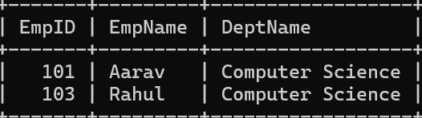

Q8. Theta Join – Greater Than
Use a Theta Join to display employees whose salary is greater than a salary grade's minimum salary.
SQL Command:
SELECT E.EmpName, E.Salary, S.Grade, S.MinSalary
FROM Employees E
INNER JOIN SalaryGrades S
ON E.Salary > S.MinSalary;
OUTPUT:
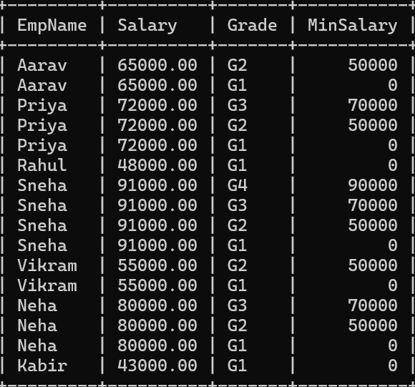

Q9. Theta Join – Salary Range
Assign each employee to the correct salary grade using >= and <= in the join conditon.
SQL Command:
SELECT E.EmpName, E.Salary, S.Grade
FROM Employees E
INNER JOIN SalaryGrades S
ON E.Salary >= S.MinSalary
AND E.Salary <= S.MaxSalary;
OUTPUT:
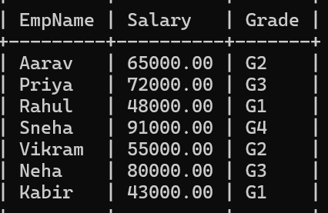

Q10. Theta Join – Less Than
Display employee names and salary grades where employee salary is less than the grade maximum salary.
SQL Command:
SELECT Employees.EmpName,
SalaryGrades.Grade,
SalaryGrades.MaxSalary
FROM Employees
INNER JOIN SalaryGrades
ON Employees.Salary < SalaryGrades.MaxSalary;
OUTPUT:

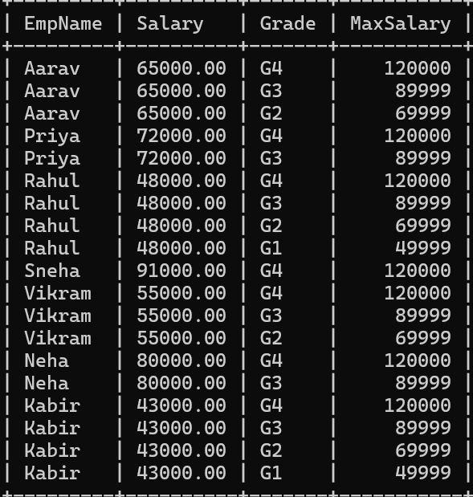

Q11. Theta Join – Greater Than or Equal
Display employee name, salary, and grade where employee salary is >= the grade minimum.
SQL Command:
SELECT Employees.EmpName,
Employees.Salary,
SalaryGrades.Grade,
SalaryGrades.MinSalary
FROM Employees
INNER JOIN SalaryGrades
ON Employees.Salary >= SalaryGrades.MinSalary;
OUTPUT:
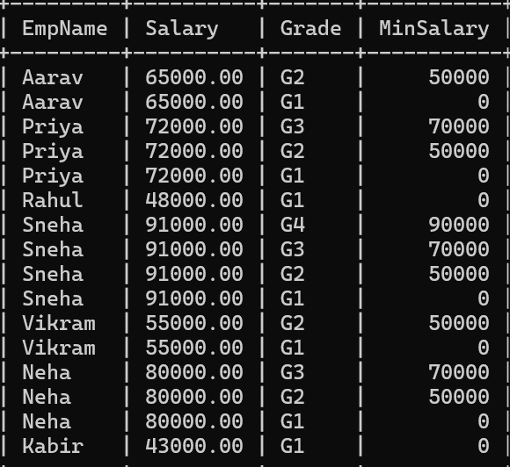

Q12. Natural Join
Use NATURAL JOIN to display employee names, DeptID, and department names. Do not write an ON conditon.
SQL Command:
SELECT EmpName,
DeptID,
DeptName
FROM Employees
NATURAL JOIN Departments;
OUTPUT:
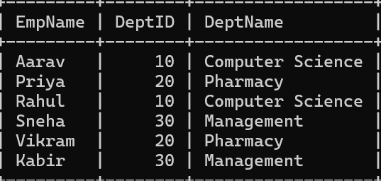

Q13. Natural Join with Filter
Using NATURAL JOIN, display employees belonging to the department located in Block B. SQL Command:
SELECT EmpName,
DeptName,
Location
FROM Employees
NATURAL JOIN Departments
WHERE Location = 'Block B';
OUTPUT:
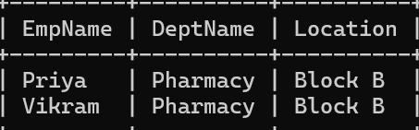

Q14. Natural Join with Salary
Using NATURAL JOIN, display employee name, department name, and salary for salaries >= 70000.
SQL Command:
SELECT EmpName,
DeptName,
Salary
FROM Employees
NATURAL JOIN Departments
WHERE Salary >= 70000;
OUTPUT:
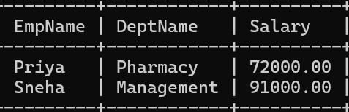

Q15. Inner Join + ORDER BY
Display matched employee name, department, and salary sorted from highest salary to lowest.
SQL Command:
SELECT Employees.EmpName,
Departments.DeptName,
Employees.Salary
FROM Employees
INNER JOIN Departments
ON Employees.DeptID = Departments.DeptID
ORDER BY Employees.Salary DESC;
OUTPUT:
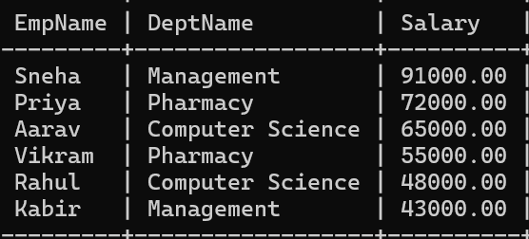

Q16. DISTINCT Departments
Display dis nct department names that have at least one matching employee.
SQL Command:
SELECT DISTINCT Departments.DeptName
FROM Employees
INNER JOIN Departments
ON Employees.DeptID = Departments.DeptID;
OUTPUT:
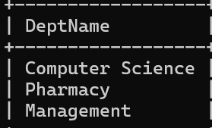
Q17. Employee Count
Use INNER JOIN, GROUP BY, and COUNT to show the number of employees in each matched department.
SQL Command:
SELECT Departments.DeptName,
COUNT(Employees.EmpID) AS EmployeeCount
FROM Employees
INNER JOIN Departments
ON Employees.DeptID = Departments.DeptID
GROUP BY Departments.DeptName;
OUTPUT:
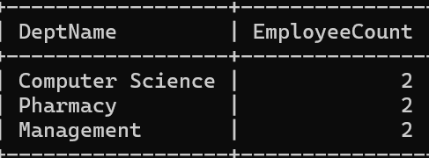

Q18. Average Salary
Use INNER JOIN and GROUP BY to calculate average salary for each matched department. SQL Command:
SELECT Departments.DeptName,
AVG(Employees.Salary) AS AverageSalary
FROM Employees
INNER JOIN Departments
ON Employees.DeptID = Departments.DeptID
GROUP BY Departments.DeptName;
OUTPUT:
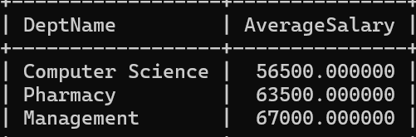

Q19. HAVING
Show departments whose average employee salary is greater than 60000.
SQL Command:
SELECT Departments.DeptName,
AVG(Employees.Salary) AS AverageSalary
FROM Employees
INNER JOIN Departments
ON Employees.DeptID = Departments.DeptID
GROUP BY Departments.DeptName
HAVING AVG(Employees.Salary) > 60000;
OUTPUT:
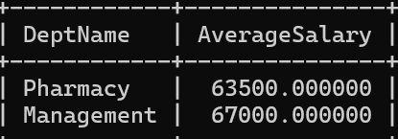

Q20. Highest Paid Employee
Find the highest-paid employee among matched employees and display name, department, and salary.
SQL Command:
SELECT Employees.EmpName,
Departments.DeptName,
Employees.Salary
FROM Employees
INNER JOIN Departments
ON Employees.DeptID = Departments.DeptID
ORDER BY Employees.Salary DESC
LIMIT 1;
OUTPUT:
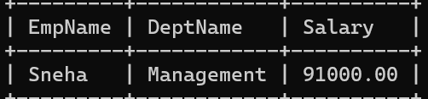

Q21. IN Condition
Display employees working in either Computer Science or Pharmacy.
SQL Command:
SELECT Employees.EmpID,
Employees.EmpName,
Departments.DeptName
FROM Employees
INNER JOIN Departments
ON Employees.DeptID = Departments.DeptID
WHERE Departments.DeptName IN ('Computer Science', 'Pharmacy');
OUTPUT:
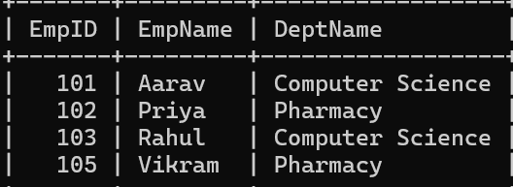

Q22. Multiple WHERE Conditons
Display employees from Delhi or Pune whose salary is at least 50000, with department
names.
SQL Command:
SELECT Employees.EmpID,
Employees.EmpName,
Employees.City,
Employees.Salary,
Departments.DeptName
FROM Employees
INNER JOIN Departments
ON Employees.DeptID = Departments.DeptID
WHERE Employees.City IN ('Delhi', 'Pune')
AND Employees.Salary >= 50000;
OUTPUT:
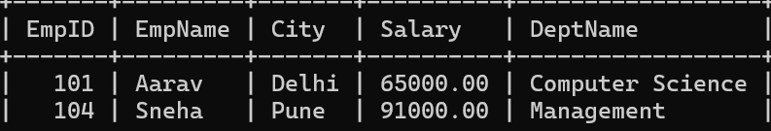

Q23. Matched Rows Observation
Use INNER JOIN to display all matched employees. Observe which employee is excluded because no department has DeptID 50.
SQL Command:
SELECT Employees.EmpID,
Employees.EmpName,
Employees.DeptID,
Departments.DeptName
FROM Employees
INNER JOIN Departments
ON Employees.DeptID = Departments.DeptID;
OUTPUT:

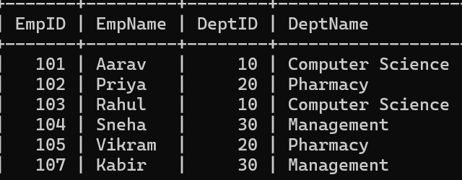

Q24. Natural Join + GROUP BY
Using NATURAL JOIN, count employees in each department.
SQL Command:
SELECT DeptName,
COUNT(EmpID) AS EmployeeCount
FROM Employees
NATURAL JOIN Departments
GROUP BY DeptName;
OUTPUT:
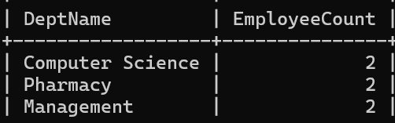

Q25. Final Challenge
Use an equality-based INNER JOIN to find departments whose total employee salary is greater than 100000. Display department name and total salary.
SQL Command:
SELECT Departments.DeptName,
SUM(Employees.Salary) AS TotalSalary
FROM Employees
INNER JOIN Departments
ON Employees.DeptID = Departments.DeptID
GROUP BY Departments.DeptName
HAVING SUM(Employees.Salary) > 100000;
OUTPUT:
